What are the Different Motherboard Components and Their Functions?
Understanding your motherboard components and functions is simple... Join us as we explain the different parts of a motherboard with pictures.
At the first glance, the components of a motherboard can appear complicated... even daunting to some. How are we supposed to figure out this big jumble of connectors, ports, slots, sockets and heat sinks?
Good news: Finding your way around a motherboard isn't hard... You simply need to be able to identify the different motherboard parts and understand their functions.
Join us as we take you on a guided tour of the different motherboard components (complete with photos and plain English descriptions):
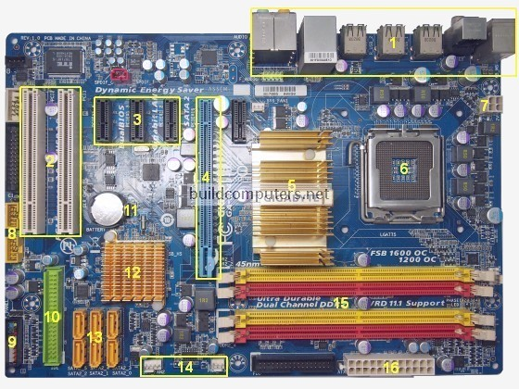
4
1. Back Panel Connectors & Ports | Connectors and ports for connecting the computer to external devices such as display ports, audio ports, USB ports, Ethernet ports, PS/2 ports etc. See image below for a close-up view.  For details on the individual back panel ports, click here for our guide to computer cable connections.
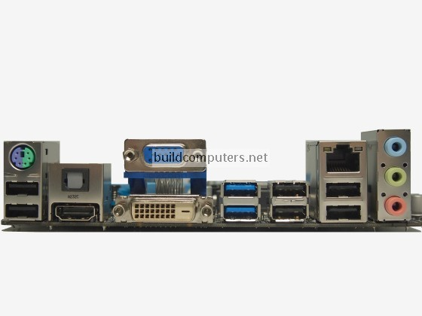
2. PCI Slots | PCI: Peripheral Component Interconnect  Slot for older expansion cards such as sound cards, network cards, connector cards. See image below for a close-up view.  Have been largely replaced by PCI-Express x1 slots (see motherboard parts #3 below).
3. PCI Express x1 Slots | Slot for modern expansion cards such as sound cards, network cards (Wi-Fi, Ethernet, Bluetooth), connector cards (USB, FireWire, eSATA) and certain low-end graphics cards. See image below for a close-up view.
4. PCI Express x16 Slot | Slot for discrete graphic cards and high bandwidth devices such as top-end solid state drives. See image below for a close-up view.
5. Northbridge | Also known as Memory Controller Hub (MCH).  Chipset that allows the CPU to communicate with the RAM and graphics card.  Beginning from Intel Sandy Bridge in 2011, this motherboard component is no longer present as it has been integrated within the CPU itself.
6. CPU Socket | Insert CPU here. To learn how to install a CPU, click here for our guide to installing a CPU.
7. ATX 12V Power Connector | Connects to the 4-pin power cable of a power supply unit which supplies power to the CPU.

8. Front Panel USB 2.0 Connectors | Connects to USB 2.0 ports at the front or top of a computer case. See image above for a close-up view.
9. Front Panel Connectors | Connects to the power switch, reset switch, power LED, hard drive LED and front audio ports of a computer case. See image above for a close-up view.  For more details on the individual front panel ports, click here for our guide to installing a motherboard.
10. IDE Connector | Connects to older hard drive disks and optical drives for data transfer. See image above for a close-up view.  Have been replaced over by SATA connectors (see motherboard component #13 below).
11. CMOS Battery | Supplies power to store BIOS settings and keep the real-time clock running. See image above for a close-up view.  The CMOS battery found on most motherboards is the CR2032 lithium coin cell.
12. Southbridge | Also known as the Input/Output Controller Hub (ICH).  Chipset that allows the CPU to communicate with PCI slots, PCI-Express x 1 slots (expansion cards), SATA connectors (hard drives, optical drives), USB ports (USB devices), Ethernet ports and on-board audio.
13. SATA Connectors | Connects to modern hard disk drives, solid state drives and optical drives for data transfer. See image above for a close-up view.
14. Fan Headers | Supplies power to the CPU heat sink fan and computer case fans. See image above for a close-up view.
15. RAM Slots | Insert RAM here. To learn how to install RAM, click here for our guide to installing RAM.
16. ATX Power Connector | Connects to the 24-pin ATX power cable of a power supply unit which supplies power to the motherboard.

17. mSATA Connector | Connects to a mSATA solid state drive. In most cases, this SSD is used as cache to speed up hard disk drives, but it's possible to re-purpose it as a regular hard drive.
18. Front Panel USB 3.0 Connector | Connects to USB 3.0 ports at the front or top of the computer case.
19. Power & Reset Button | Onboard button to turn on, turn off and reboot the computer.  This motherboard component is more common among high end boards.
Recommended Motherboard CPU Combos
Budget Computer: Intel Celeron G1820 CPU + MSI H81M-E34 Motherboard
Mid Range Computer: Intel Core i3-4160 CPU + Gigabyte GA-B85M-D3H Motherboard
Gaming Computer: Intel Core i5-4690K CPU + MSI Z97 Gaming 7 Motherboard
Home Theater PC: AMD A6-6400K APU + MSI A88XI AC Motherboard
Click here for our buyer's guide to the best motherboard CPU combos.
MOTHERBOARD GUIDE
- What is a Motherboard and How It Works
- Best Motherboard CPU Combos
- Motherboard Components and Parts
- Motherboard Form Factors
- How to Choose a Mini ITX Motherboard
- How to Choose a Micro ATX Motherboard
- How to Choose an ATX Motherboard
- Intel Motherboard Socket Types
- AMD Motherboard Socket Types
- The Difference Between USB 2.0 and 3.0
- How to Install a Motherboard
Share this page:
Share This Page with Others - Click Here for Your HTML Link Code

- Home
- How to Build a PC
- CPU
- Motherboard
- RAM
- Power Supply
- Hard Drive
- Computer Case

Best Motherboard CPU Combos 2014

 | Contact Us | Disclosure | Disclaimer | Privacy Policy
Copyright © 2012-2015 buildcomputers.net
ShareThis Copy and Paste

Share
- See more at: http://www.buildcomputers.net/motherboard-components.html#sthash.khD1ZwpM.dpuf

